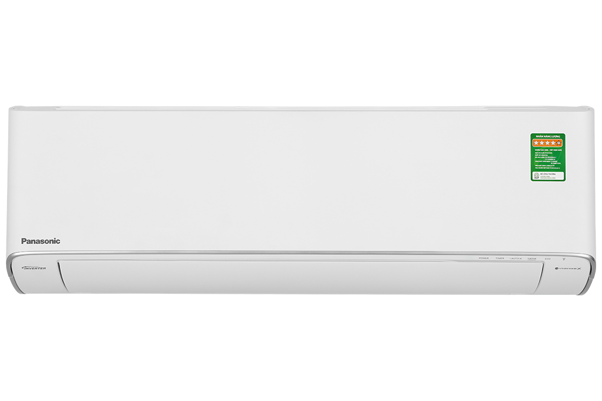

**13,340,000 VND**

(-4%)

**Technical specifications of Panasonic Inverter 1 HP CU/CS-XU9ZKH-8 air conditioner**

* Machine Type:

1 way (cooling only) With Inverter

* Cooling capacity:

1 HP - 8,700 BTU

* Effective cooling range:

Under 15m² (from 30 to 45m³)

* Dust filter, antibacterial, deodorant:

Nanoe™ X generation 3 air filtration technology Nanoe-G filters PM 2.5 fine dust

* Power saving technology:

ECO integrates AI Inverter

* Rapid cooling:

iAuto-X

* Utilities:

Humidity control mode Night sleep mode Sleep for the elderly and children Self-diagnosis function Super quiet operation Quiet timer to turn on and off Automatically restart when power is available Cleaning inside the indoor unit: Inside Cleaning Condition Controlled by phone, with wifi

* Power consumption:

0.65 kW/h 5 stars (Energy efficiency 6.16)

* Cooler:

Length 87 cm - Height 29.5 cm - Thickness 22.9 cm - Weight 10 kg

* Outdoor:

Length 72 cm - Height 51.1 cm - Thickness 26.8 cm - Weight 18 kg

Introducing the company 

- Japanese brand.  
- Established in 1918. Panasonic entered the Vietnamese market very early, in the 1950s.  
- Panasonic is famous for its refrigerators, air conditioners, televisions and household appliances such as microwaves, fans, air conditioners. blender...  
- Panasonic products are famous for their high durability, energy saving, and beautiful designs.

[**Detailed review of Panasonic Inverter 1 HP CU/CS-XU9ZKH-8 air conditioner**](https://www.dienmayxanh.com/kinh-nghiem-hay/danh-gia-chi-tiet-may-lanh-panasonic-inverter-1-hp-1537690)

[***Panasonic Inverter 1 HP CU/CS-XU9ZKH-8***](https://www.dienmayxanh.com/may-lanh/panasonic-inverter-1-hp-cu-cs-xu9zkh-8#2-gia)***air conditioner blows cold air into your room under 15m² quickly with iAuto-X fast cooling technology, 1 HP capacity, saves electricity with integrated ECO technology Combined with AI and Inverter, keep the room space clean, sterilize, and deodorize optimally with Nanoe™ X, Nanoe-G technology, controlled by phone, with convenient wifi.***

**Design overview**

Cooler

- [Panasonic air conditioner](https://www.dienmayxanh.com/may-lanh-panasonic) has a trendy appearance with pure white tones and prominent silver borders creating a highlight for the overall design to be more beautiful and luxurious. The rectangular shape is suitable for installation in your living room, bedroom, or office space.

Outdoor

- Minimalist design, with a good material shell for high durability and solidity, protecting safety details from the impact of external environmental factors.

- Equipped with **copper gas pipes, heatsinks made from aluminum that**  conducts heat well, limits corrosion, maintains optimal cooling efficiency, and can be used for a long time.

[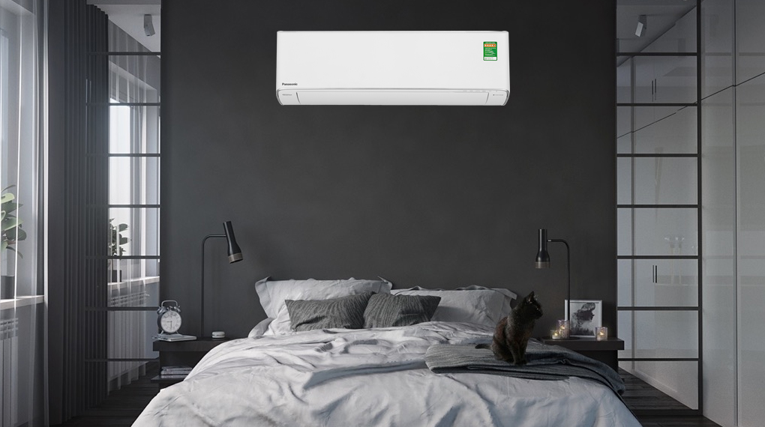](https://cdn.tgdd.vn/Products/Images/2002/303867/may-lanh-panasonic-inverter-1-hp-cu-cs-xu9zkh-8-190323-115519.jpg)

*\*Images are for illustration purposes only*

**Refrigeration technology**

- Meets cooling needs within a range of less than 15m² (from 30 to 45m³) with a capacity of  **1 HP.**

[- Supports iAuto-X](https://www.dienmayxanh.com/kinh-nghiem-hay/cac-che-do-lam-lanh-nhanh-thuong-gap-tren-may-lanh-837183#iauto-x) technology   with the combination of P-TECH technology to increase the compressor and blower capacity, allowing the room temperature to quickly reach the temperature level you have set in a short time. Makes you feel instantly cool.

**Air blowing mechanism**

**- Customized automatic up, down, left and right control** device allows the ability to spread cold air evenly and widely throughout the room, so that everyone living in the room space feels comfortable and relaxed.

**Power saving technology**

[- Inverter](https://www.dienmayxanh.com/kinh-nghiem-hay/the-nao-la-may-lanh-inverter-628934) technology  uses an inverter compressor to adjust rotation so that the cooling temperature is maintained stable, saves energy, and the equipment operates smoothly and efficiently.

- [ECO integrates AI](https://www.dienmayxanh.com/kinh-nghiem-hay/nhung-cong-nghe-noi-bat-tren-may-lanh-panasonic-1242950#eco-tich-hop-AI) , technology that automatically adjusts the appropriate power reduction level from 5% - 50% and the cooling time needed to keep the room temperature at a suitable level but reduce maximum power consumption.

- [Air conditioners](https://www.dienmayxanh.com/may-lanh)  using **R-32** gas  help deep clean, reduce emissions by up to 75%, limit energy waste, and enhance environmental protection.

- Energy label:  **5 stars** (energy efficiency 6.16).

**Air filtering ability**

**- Nanoe-G** technology  filters out dirt and fine dust PM 2.5, making the room space cleaner.

- Nanoe **™ _** _

Panasonic and Texcell have shown test results that Nanoe™️ This test was performed under closed laboratory conditions and is not designed for evaluation in an uncontrolled living space.

**Below are the test results and certificate of Nanoe™️ X technology being able to inhibit Corona virus in laboratory conditions.**

[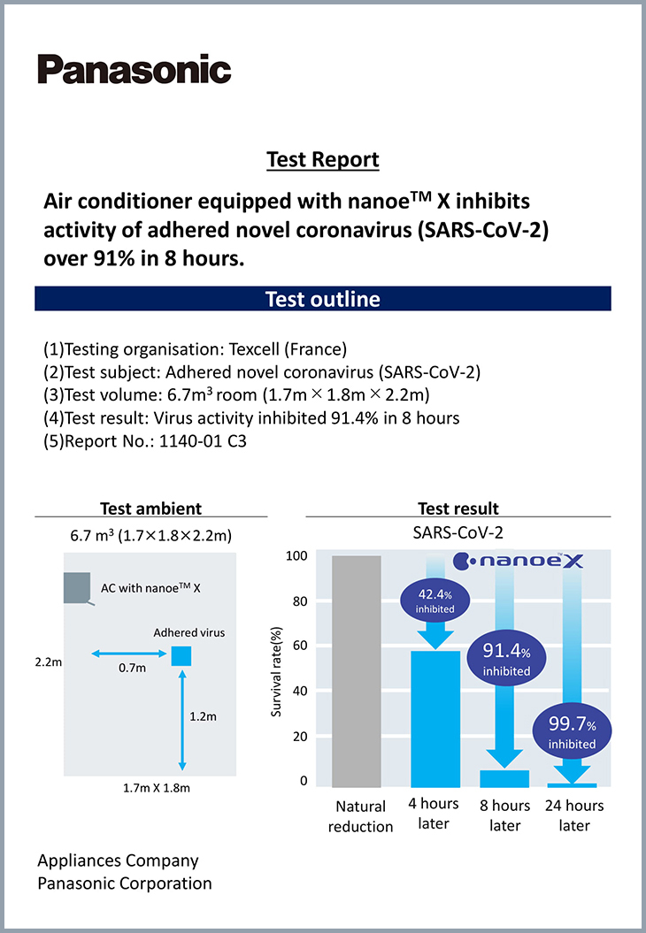](https://cdn.tgdd.vn/Products/Images/2002/303867/may-lanh-panasonic-inverter-1-hp-cu-cs-xu9zkh-8-190323-115728.jpg)

*Test results of Nanoe™️ X technology have the ability to inhibit Corona virus in laboratory conditions.*

[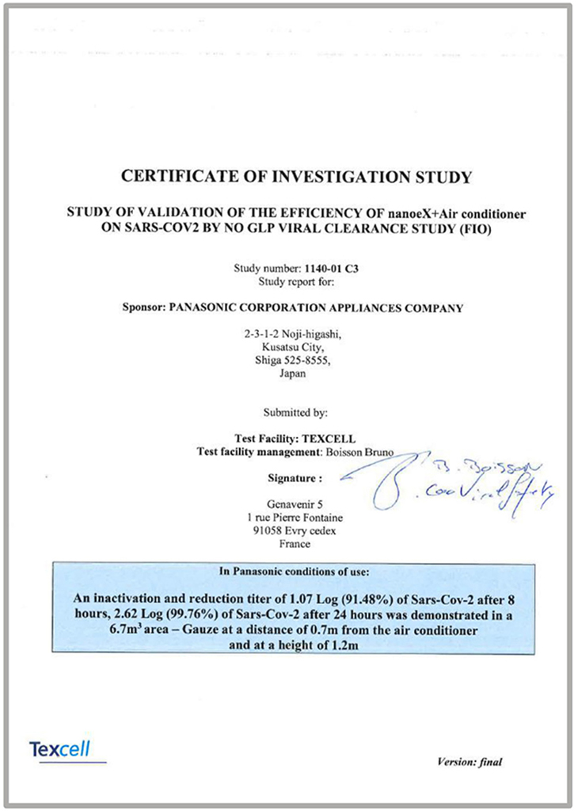](https://cdn.tgdd.vn/Products/Images/2002/303867/may-lanh-panasonic-inverter-1-hp-cu-cs-xu9zkh-8-190323-115753.jpg)

*Nanoe™️ X technology certificate is capable of inhibiting Corona virus in laboratory conditions.*

*\* Texcell is the first organization of the Pasteur Institute of Paris established in 1997 specializing in global research on virus testing, virus removal, immunity provision, etc. With more than 30 years of experience and has Based at the Pasteur Institute Paris, Texcell is recognized for its virus expertise with a wide range of procedures to detect potential agents.*

**Utilities**

-  [Controlled by phone, with wifi](https://www.dienmayxanh.com/may-lanh-co-wifi-chinh-bang-dien-thoai) : the device can connect to the phone via wifi and flexibly customize the  [Inverter air conditioner](https://www.dienmayxanh.com/may-lanh?g=may-lanh-inverter) function  remotely through the supplier's application.

-  **Humidity control mode** : keeps the room airy, dry, and no longer uncomfortable with humidity.

- **Cleaning inside the indoor unit - Inside Cleaning** : removes moisture in the indoor unit, cleans automatically, ensuring cooling capacity and smooth and effective operation of the device.

-  [Self-diagnosis function](https://www.dienmayxanh.com/kinh-nghiem-hay/cac-che-do-thuong-thay-tren-may-lanh-795107#doan-loi) : detects air conditioner problems quickly, from which users can easily identify, search, and fix appropriately, helping to save repair costs.

There are also other utilities such as:  [timer to turn on and off](https://www.dienmayxanh.com/kinh-nghiem-hay/cac-che-do-thuong-thay-tren-may-lanh-795107#hen-gio) ,  [automatic restart when there is power](https://www.dienmayxanh.com/kinh-nghiem-hay/cac-che-do-thuong-thay-tren-may-lanh-795107#tu-khoi-dong) ,...

*Overall, the Panasonic Inverter 1 HP CU/CS-XU9ZKH-8 air conditioner integrates many technologies to help increase cooling speed, keep room air clean, pure, and save energy with iAuto-X technology. , ECO integrates AI, Inverter, Nanoe™ X, Nanoe-G, controlled by phone via wifi,...*